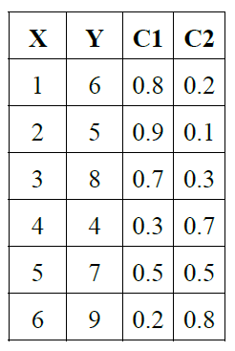

Practice Fuzzy C-Means clustering on the sample dataset given.

The dataset given is only for reference. Students can chose any dataset of their choice.